# Neuroscan (SynAmps2) Acquisition Driver for Open-ViBE

The following is a brief guide for the use of the Acquisition driver developed to enable Open-ViBE software to interface with SynAmps2 amplifiers, and Neuroscan Edit 4.3 software. Edit 4.3 software has a Client/Server option, which we have used to facilitate communication between the Edit program (Server) and the open-ViBE acquisition driver (Client). For our purposes, we have a LAN, which has Edit running on one system (Server), and Open-ViBE Acquisition (Client) and Designer running on a second computer.

The basic steps for connecting the two pieces of software across the LAN are outlined below.

## Step 1 – Power up, open software

Server – Open Edit software, load appropriate setup file etc.

Client – Open Open-ViBE Acquisition Driver, and Designer

## Step 2 – Establish LAN connection

Click on the ‘S’ icon in the toolbar (see Figure 1).

## C:\Documents and Settings\DaWhite\My Documents\My Pictures\edit server.jpg

***Figure 1.*** Edit software, with Server icon highlighted.

This will bring up the Server options, where you must enter the details of your connection (See Figure 2). If you check ‘Monitor packets’, then you will receive information about the connection at the bottom of your Edit Window (when it is connected, how much data has been sent).

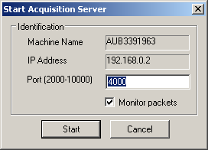

***Figure 2.*** Server options.

NOW, on the Client machine, you must select the appropriate settings in the Acquisition Server box, in order to establish the connection (Figure 3). You can edit the properties of the acquisition by opening the Properties box (Black box, Figure 3). This will bring up another box, which has a number of details of the acquisition (see Figure 4). **\*\*IMPORTANT** The Neuroscan acquisition deals with events as a separate channel of data, for this reason, when you set the number of channels, you must ADD ONE to the total number of active channels in the recordings. This channel will appear as the last channel in your OV data, but you can easily ignore this channel, using the ‘Channel selection’ box in the OV Designer.**

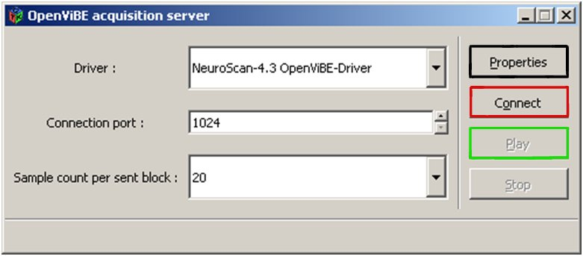

***Figure 3.*** Acquisition Driver GUI.

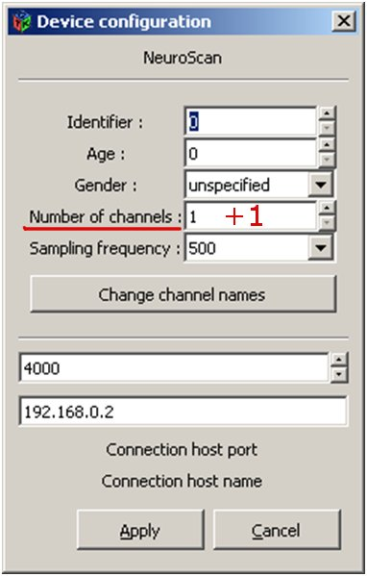

***Figure 4.*** Settings for Acquisition Driver, when using SynAmps2 driver, the number of channels is N+1, as events are treated as a separate channel.

Once all of your settings are as desired, click Apply, and Connect (Red box, Figure 3). If the connection is successful, the bottom of the Driver box should indicate this (Figure 5). The bottom of the Edit window on the Server machine should now also indicate the presence of a client connection.

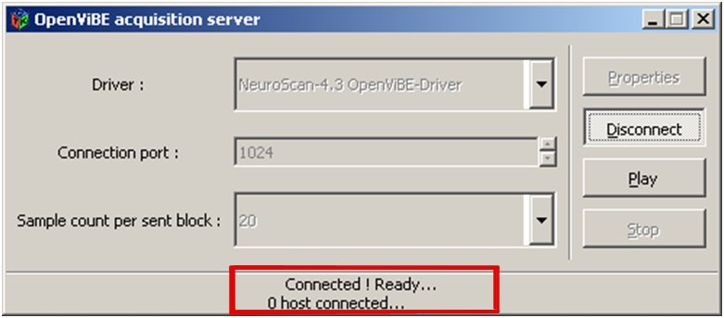

***Figure 5.*** Driver box, after successful connection.

## Step 3- Begin Acquisition

**\*\*IMPORTANT** The driver is relatively temperamental, it requires that when you start sending data, you must first click on ‘PLAY’ in the Edit Software (Server machine), then ‘PLAY’ in the Driver box, THEN (once you have data being sent and received) you can push play on a scenario in the OV Designer. This is also spelt out in the code for the driver (see Figure 6).**

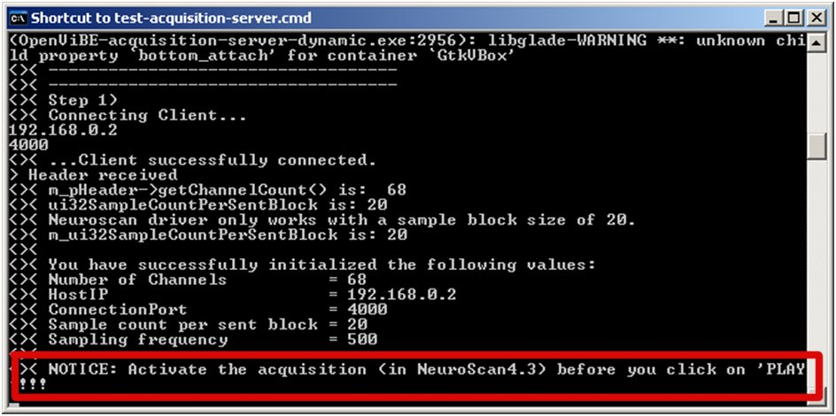

***Figure 6.***Notice regarding the order in which to begin acquisition.

## To begin Acquisition:

1. Press play on Edit computer

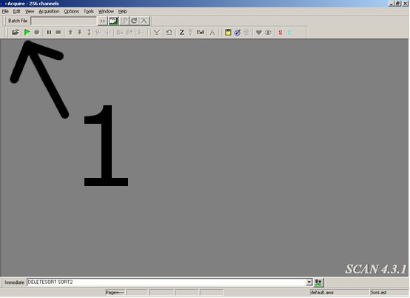

1. Immediately after (to avoid excessive buffering), press Play in Acquisition Driver

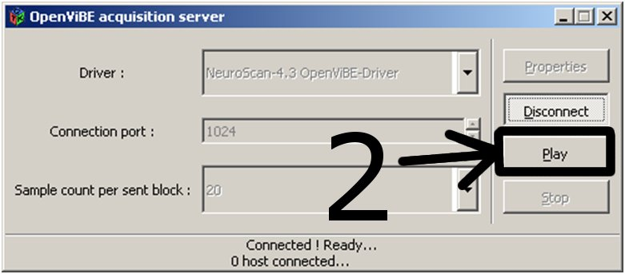

1. Start your Designer Scenario.

